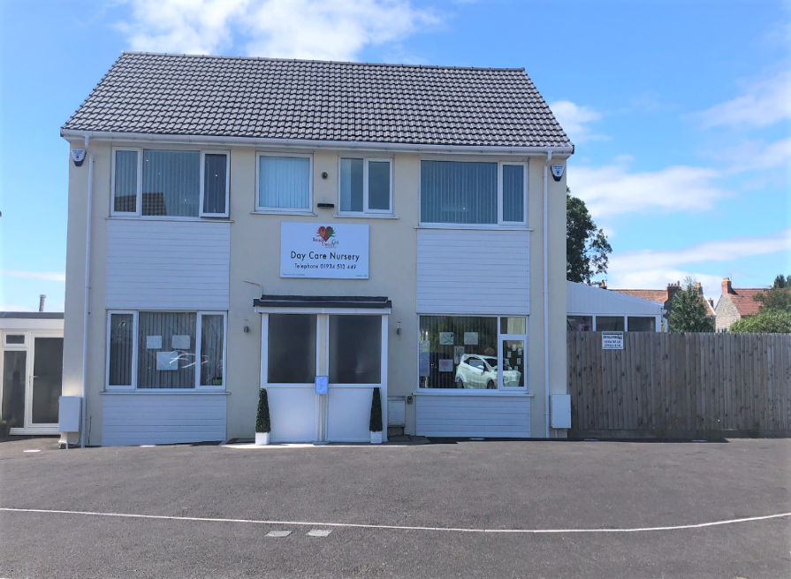

WELCOME TO READY STEADY GO CHILDCARE
Tel: 01934 513449 Established:2001



Our Preschool

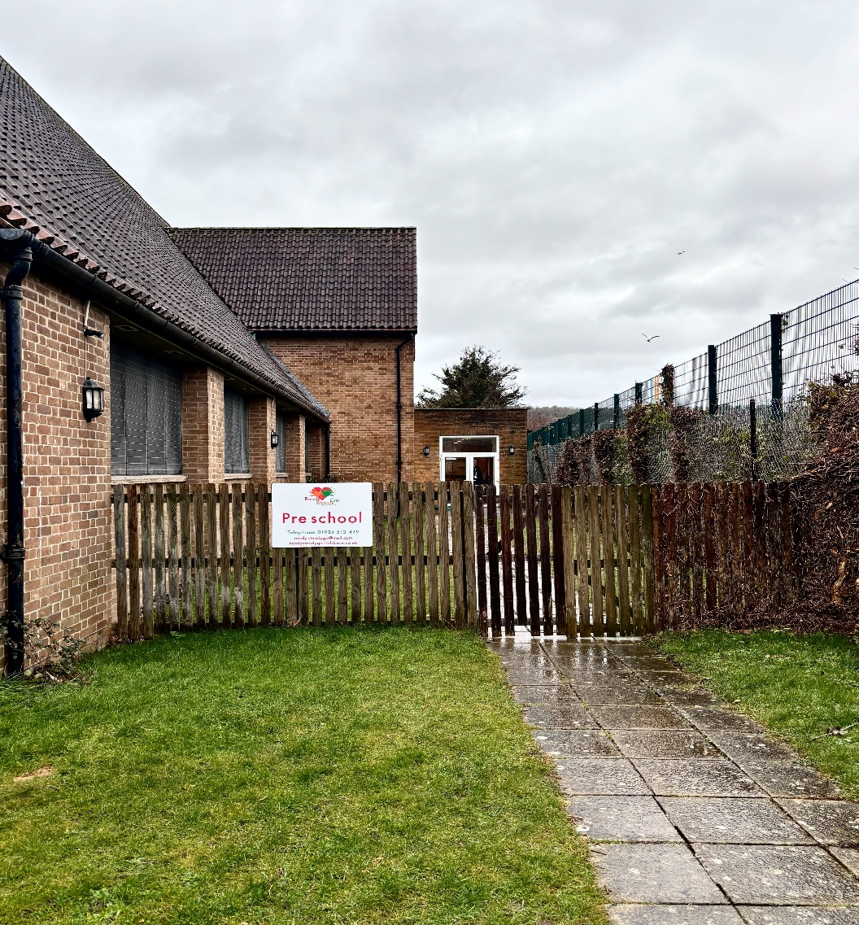

Contents
- Mission Statement/About Us
- Price List
- Application to Join: Nursery or Preschool
- Government Funding Additional Charges
- Menu
- Our Daily Routines
- Our 5 Golden Rules

Sam Filer, Tara Maher & all the staff at Ready Steady Go would like to thank you for enquiring for a place at our Nursery. We hope this pack provides you with all the information you require, but please do not hesitate to contact us should you need any further information.

Telephone: 01934 513449
Email: ready-steadygo@mail.com
Website: www.readysteadygo-childcare.co.uk

Ofsted Registration No: EY541629

OUR MISSION STATEMENT
HOME FROM HOME WE TREAT YOUR CHILD AS IF THEY’RE OUR OWN
ABOUT US
Ready Steady Go Childcare was established in 2001.
We (Sam & Tara, sisters) are proud to own this nursery and preschool. We are both mothers and have enjoyed seeing our own children, grandchildren, family & friends come to our settings over the years. We have a fantastic team of staff who are dedicated, qualified, experienced and friendly, and many of them have been with us long enough to see our little ones grow into adulthood. Our latest Ofsted Inspection in May 2024 rated us “Good” in all areas. (The full report can be seen on the Ofsted website or a copy can be provided upon request).
Our Nursery and Preschool settings are both set in residential areas within a local communities providing the children with excellent opportunities to explore their surroundings and natural world around them as part of their routine. The nursery is registered for 75 children each day from birth to 3 years of age, and offers several rooms for our Babies, Tiny Tots and Toddlers. The Preschool is registered for 32 children form ages 3 to 5 years and offers the children a welcoming hall within the local church.
We are an all-inclusive and diverse setting welcoming children from all backgrounds, cultures, ethnic minorities or with any special educational needs or disabilities into our Home from Home environments. Children will receive a balance of teaching, play and care so they can learn, develop and expand upon their individual personalities to the best of their ability.
We offer a home cooked menu providing children with a variety of healthy and nutritional foods. We pride ourselves on our 5 star Food & Hygiene rating which we have been consistently been awarded for all our Environmental Health inspections.

We have large outdoor gardens at the Nursery offering a natural and stimulating environment with many physical and creative resources for all the children to enjoy every day, along with our many outings. Preschool children have an outstanding outdoor area to explore, and enjoy our Forest and Beach Day trips giving them an enriched experience of the changes throughout the seasons. Promoting these outdoor experiences allows many opportunities for the children to play, explore and extend upon their physical development, whilst gaining an understanding of the world and nature around them.

All our children are promoted and encouraged to develop in all areas of learning through play, structured activities and exploration with guidance from the Early Years Foundation stage (EYFS), allowing them to meet their full potential in preparation for their onward transmission to school and future lives.
We completely understand how choosing a Nursery and Preschool is such an important decision for any parent and carer, which is why the security of a fully safeguarded, warm & homely environment is of imperative importance to us. We continually strive to promote and develop excellent learning as your little one builds in confidence, and together with your vital input, we see them grow and move towards the next stage of their lives.

PRICE LIST APRIL 2026
Nursery
Price | Age | Session
£77.00 | 0-2 Years | Full Day
£76.50 | 2-3 Years | Full Day
Preschool
£60.40 | 3-5 Years | 8am – 4pm
£75.50 | 3-5 Years | 8am – 6pm
Government Funded Additional Fees
£1.60 | Meals 55p Essentials 55p Activities 55p  (Fee per funded hour)
Other Fees
£78.00 | Adhoc Full Day
£43.00 | Adhoc Half Day (8am-1pm / 1pm-6pm)
£13.60 | 7am Early Start / 7pm Late Finish
£10.20 | 7.15am Early Start / 6.45pm Late Finish
£6.80 | 7.30am Early start / 6.30pm Late Finish
£3.40 | 7.45am Early start / 6.15pm Late Finish
£100 | Booking Fee (private hours)
£10 | Change of session / Admin Fee
£1.50 | Late Fee per min (after session)
We accept all Government funding & Tax Free childcare towards your nursery fees

Nursery Application to Join
We are delighted you would like your child to join Ready Steady Go. Please complete this form and hand back to a member of staff. Thank you.
Name of child: …………………………………………...............DOB: …….…...... Gender:..
Names of Parents/Carers:…………...........................................................................
Address:……………………………………………………………………..........................................
Telephone No:…………………………………….…………… Email (access to your child’s online learning diary (FAMLY): …………………..…………………….
Start Date required: …………….......................................

Please Tick  Days required | 8.00am-6.00pm |  | 7.00 | 7.15 | 7.30 | 7.45 | 18.15 | 18.30 | 18.45 | 19.00
Monday
Tuesday
Wednesday
Thursday
Friday
Booking Fee: £100 To secure your place for 6 months and includes home visit, settling in sessions & top/bag. This is to be paid once the office have contacted you to confirm your sessions.
Parents/Carers signature: .................................................. Date: .........................
We will contact you nearer the time of your child’s start date to arrange their settling in sessions. This will give us an opportunity to complete the relevant paperwork with the office. If you have any questions in the meantime please do contact us. We look forward to meeting you and your little one very soon.
Date Payment Received…………………..Cash/Bank Staff Name:….…………………….
Bank Account No: 60122460. Sort Code: 309951
Preschool Application to Join
We are delighted you would like your child to join Ready Steady Go Pre-school. Please complete this form and hand back to a member of staff. Thank you.
Name of child: …………………………………………...............DOB: …….…...... Gender:..
Names of Parents/Carers:…………...........................................................................
Address:……………………………………………………………………..........................................
Telephone No:…………………………………….…………… Email (access to your child’s online learning diary (FAMLY) …….……………………………………
Start Date required: ……………......................................
Please Tick  Days required | 8am -6pm | 8am – 4pm | 7.30am | 7.45am
Monday
Tuesday
Wednesday
Thursday
Friday

Booking Fee: £100 To secure your place for 6 months and includes home visit, settling in sessions & top/bag. This is to be paid once the office have contacted you to confirm your sessions.
Parents/Carers signature: .................................................. Date: .........................
We will contact you nearer the time of your child’s start date to arrange their settling in sessions. This will give us an opportunity to complete the relevant paperwork. If you have any questions in the meantime, please do contact us. We look forward to meeting you and your little one very soon.
Date payment Received…………....………. Cash/Bank Staff Name………………………….
Bank Account No: 60122460 Sort Code: 309951
A breakdown of our Additional Charges on your Government Funded hours
Meals
Breakfast | 2 Course Lunch | 2 Course Tea
Morning Snack | Afternoon Snack | Fruit throughout day
Drink &Treats on outings (ie. ice creams, lollies, hot choc, chips. Cakes)

Essentials
Paediatric First Aid | Food Hygiene | Fire Safety
Safeguarding | SENCO | Makaton
Emergency Medical Supplies | Bedding | Laundry resources
Enhanced staff ratios | Hand soap | Cutlery
Aprons (Play/Changing) | Pots & Pans | Bibs
Sanitizer | Toilet roll | Gloves
Wet wipes (meals/activities) | Nappy Bags | Clinical/Commercial Waste
Malleable resources | Spare clothes | Settling in Sessions
Sensory equipment/toys | Flannels

Activities
Boogie Beats | Swimming | Football
Fruit & Veg Shop | Ballet | Sports Day
Graduation | Parks & Picnics | Walking Trains
Forest Days | World of Stuff | Children’s Reins
Buggies | Education speakers ie Police | Poetry Basket
Pier & Donkey rides | Beach Days | Baking
High Vis Jackets | Elf Run | Children in Need
School Readiness Programme | Red Nose Day | Easter Bonnet Parade
Cafes | Halloween | Spare rain suits
Christmas Celebrations | Festivals | Local church
Local Museum | Health centres | Supermarket
Local Library | Cinema | Farm
Water Park | Story & Rhyme Time | The Playhouse
Duck Pond | Post Office

Our Menu



Our Enviromental Health Award for Food is 5 stars (February 2026)
Our menu has been compiled in line with the Department of Education new Safeguarding and Welfare requirements (September 2025) which ensures all early years children are provided with a healthy, nutritious and balanced diet.


Our Menu
Our menu for each week is on display outside the nursery. A full copy of the menus can be provided upon request.
Your child’s health & nutrition is crucial to their development, and our menu has been complied with this in mind. All meals are served with milk/water & are available throughout the day.
Breakfast starts their day at 8.15am with a variety of foods. This can include cereals, fruit, toast, bagels, porridge etc. (This will still be provided for later arrivals if requested)
Snack time is served twice daily at 10am & 2.30pm. This offers a little bite to eat before their main meals. This can include fruit, salad items, cheese, crackers etc
Dinner & Tea Time are at 12pm & 4.30pm and are made up of a 2 course meal.
The menu is rotated weekly to ensure all the children have the opportunity to sample different foods. Meals are served to your child’s development needs i.e. Mashed, chopped, finger and whole foods.
Our menu includes the following essential groups of foods:-
Fruit and veg, Bread, rice, potatoes, pasta, Meat, fish, eggs, beans & Dairy products Our foods accommodate all dietary needs, such as vegetarian, cultural and all known allergies, i.e. dairy, gluten, wheat and soya, as well as likes and dislikes. Please add any specific food requirements to your child’s registration form.

For the younger ones:
0 - 6 Months. Our babies have Breast or formula milk only.
6-12 months: Children under 1 will be offered a similar menu as 1-5years, but will be altered slightly to contain full fat, formula or breast milk. Their foods will exclude Honey, Salt, Sugar, Nuts, Low Fat Products, Shark, Swordfish, Marlin or Shellfish & runny eggs.



Our Daily Routine
- 7.00 Early Start
- 8.00 Welcome
- 8.15 – 8.45 Breakfast
- 9.00 Register/Circle/Story/Sing Time
- 9.15 – 12.00 Group Activities
Free Flow Outside Play/Outings/Trips/Forest Days
Sleep if required
Snack Time at 10.30am

- 12.00 – 12.30 Dinner Time
- 12.30 – 1.00 Free Flow / Children’s Choice
- 1.00 – 4.15 Group Activities
Free Flow / Children’s choice
Outside Play/Outings/Trips
Sleep if required
Snack Time at 2.30pm

- 4.30 – 5.00 Tea Time
- 5.00 – 5.45 Story Time & Quite Activities
- 6.00 Hometime
- 6.00 – 7.00 Late Finish



- We are kind and gentle
We treat adults and our peers in a kind and caring manner. We use kind hands, kind feet and kind words. We talk in a calm appropriate manner and do not raise our voices at others.
- We are respectful
We treat toys, furniture and resources with respect and do not break things. We tidy away after ourselves and take care of our belongings.

- We are responsible
We take responsibility for our actions and say sorry if we are in the wrong.

- We are good role models
We always use our manners and are polite to others. We share with our peers and listen well to others. We do not run in the nursery.

- We try to the best we can
We always try to be the best we can.
Although we’re not their parents,
We care for them each day.
We cuddle sing and read to them,
And watch them as they play.
We see each new accomplishment,
And help them grow and learn.
We understand their language,
And listen with concern.
They come to us for comfort,
And we kiss away their tears.
They proudly show their work to us,
We give the loudest cheers.
We are not their parents,
But our role is just as strong.
We nurture them and keep them safe,
Though maybe not for long.
We know someday the time may come
When we will have to part.
But we know each child we’ve cared for is forever in our hearts.

